CovidSim ABM Viral Load Model July 23/2020

From

He, X., Lau, E.H.Y., Wu, P. *et al.* Temporal dynamics in viral shedding and transmissibility of COVID-19. *Nat Med* **26,**672–675 (2020). <https://doi.org/10.1038/s41591-020-0869-5>

Liu Y, Yan LM, Wan L, et al. Viral dynamics in mild and severe cases of COVID-19. *Lancet Infect Dis*. 2020;20(6):656-657. doi:10.1016/S1473-3099(20)30232-2

“Assuming an incubation period distribution of mean 5.2 days from a separate study of early COVID-19 cases[1](https://www.nature.com/articles/s41591-020-0869-5#ref-CR1), we inferred that infectiousness started from 2.3 days (95% CI, 0.8–3.0 days) before symptom onset and peaked at 0.7 days (95% CI, −0.2–2.0 days) before symptom onset (Fig. [1c](https://www.nature.com/articles/s41591-020-0869-5#Fig1))” – He,Xi.

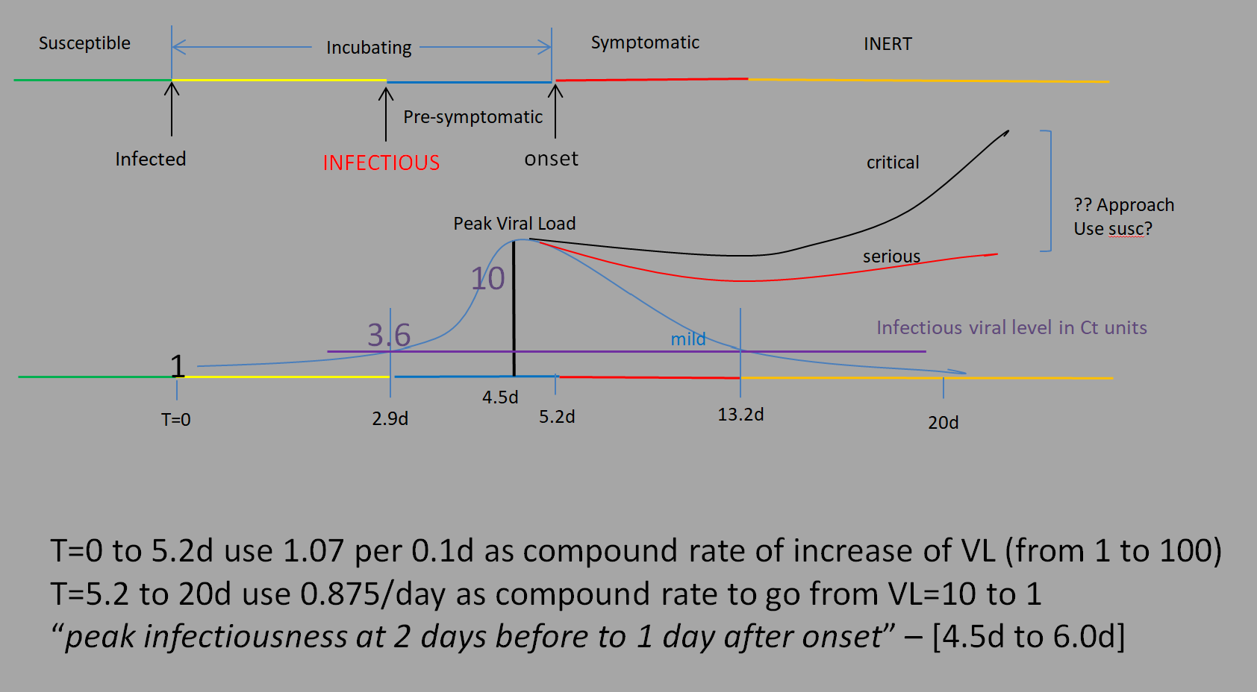

The value of 3.6 is derived from the compound rate of increase for day 2.9. The values in the He paper are for Ct units from 40 (no detectable) to 30, where 0 would be the number of cycles of replication needed to be detectable, so the higher Ct is, the lower the viral concentration. We use the inverse for simplicity, to get a monotonically increasing scale, ie 0 = 40Ct, and 10 = 30Ct..

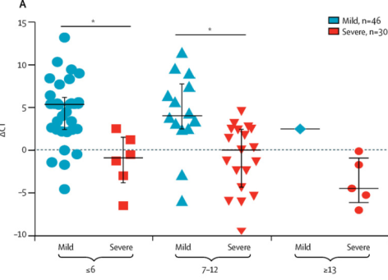The Liu paper gives us an estimate of severity, and the main observation is that these cases start with a high viral load and continue….thus at days 7-12 after onset, 9/11 of the cases with DCT less than 0 are for severe cases. Knowing that in general, 20% of cases are rated severe, we could assign a random 20% to have the “severe” viral load, though Susceptibilities are probably important, as well as initial Viral Load from the initial infection. We will have to consider this further.